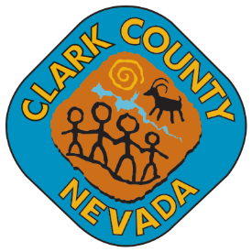**Searchlight Town Advisory Board**

**Searchlight Community Center**

**200 Michael Wendell Way**

**Searchlight, NV 89046**

January 15, 2025

6:00 p.m.

|  |
| --- |
| Board Members:    Secretary: Tammy Harris, (702) 298-0828, [tammy.harris@clarkcountynv.gov](mailto:tammy.harris@clarkcountynv.gov)  Business Address: Clark County Department of Administrative Services, 500 S. Grand Central Parkway, 6th Floor, Las Vegas, Nevada 89155      Town Liaison: Mark Moskowitz, (702) 298-0828, (702) 455-6173, [mark.moskowitz@clarkcountynv.gov](mailto:mark.moskowitz@clarkcountynv.gov)  Business Address: Clark County Department of Administrative Services, 500 S. Grand Central Parkway, 6th Floor, Las Vegas, Nevada 89155 |
|  |

**MEETING CANCELLED**

**DUE TO**

**UNFORESEEN CIRCUMSTANCES**

**Next Meeting Date**

**January 29, 2025**

**POSTING LOCATIONS:** This meeting was legally noticed and posted at the following locations:

Names of Locations

Searchlight Community Center, 200 Michael Wendell Way Searchlight, NV 89046

<https://notice.nv.gov/>